**– Software Requirement Specification**

**Version 1.0**

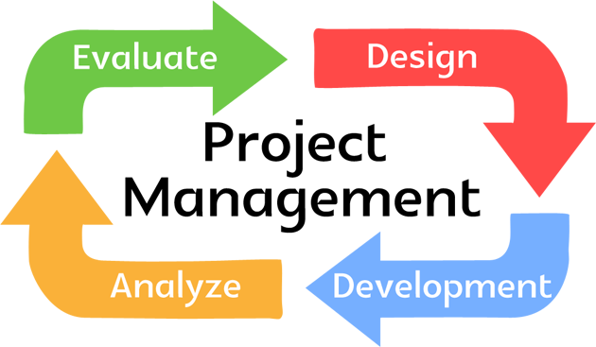

Project Management System

Prepared By:

Nevil Parmar

Roll No: CE092

Id – 18CEUBG023

Semester - 5

|  |  |  |  |  |  |  |
| --- | --- | --- | --- | --- | --- | --- |
|  |  | | **Table of Contents** | |  |  |
| 1. | | Introduction | | | | |
|  | | 1.1 | | Purpose | | |
|  | | 1.2 | | Scope | | |
|  | | 1.3 | | Definitions, Acronyms and Abbreviations | | |
|  | | 1.4 | | References | | |
|  | | 1.5 | | Technologies to be used | | |
|  | | 1.6 | | Overview | | |
| 2. | | Overall Description | | | | |
|  | | 2.1 | | Informal Requirements User wise | | |
|  | | 2.2 | | ER Diagram | | |
|  | | 2.3 | | Assumptions and Dependencies | | |
| 3. | | Specific Requirements | | | | |
|  | | 3.1 | | Functional Requirements | | |
|  | | 3.2 | | Non-Functional Requirements | | |
|  | | 3.3 | | Supplementary Requirements | | |

**1. Introduction**

* 1. **Purpose**

To develop a fully functional and user interactive online tool which can enhance and help various project management users to manage and compile their work efficiently and productively

**1.2 Scope**

* Create different users with varied roles and scopes.
* Confirm each member by providing activation codes.
* Manage all project details like tasks, deadlines, team members and resources.
* Assign different tasks to different members.
* Provide documentation to the members about the tasks being added
* Update all members about new proceedings in the project.
* Bind all the information provided by the team members at one place and show it to all others.
* Maintain start date and end date of each task
* Maintain the overall timeline of the project.
  1. **Definitions, Acronyms and Abbreviation**

**OPM** – Online Project Management.

**Admin** – Administrator.

**PM** – Project Manager.

**HTML** – Hyper Text Markup Language.

**XHTML** – extensible Hypertext Markup Language.

**HTTP** – Hypertext Transfer Protocol.

**Angular** - Angular JS

**Node** - Node JS

**1.4** **References**

IEEE SRS Format.

**1.5** **Technologies to be used**

|  |  |  |
| --- | --- | --- |
| Application Architecture | - | Microservices |
| Database Application | - | MongoDB |
| Development tool | - | Visual Studio Code |
| Web Deployment Server | - | Herokuapp |
| Designing tool | - | Adobe XD CC |

**1.6** **Overview**

This project is a tool to help in managing projects. It is more useful in current market situation where an organization is not close to a door or a city or a nation. In this case sharing document & data related to project from one corner of the world to another by using internet makes our work for easy. But still it is unmanaged to manage this work we are making this tool Online Project Management System (OPM).

**2. Overall Description**

|  |  |  |  |  |  |
| --- | --- | --- | --- | --- | --- |
|  |  |  |  | Start New |  |
|  |  |  |  | Projects |  |
|  |  |  | Administrator | Invite Project |  |
|  |  |  | Managers |  |
|  |  |  |  |  |
|  |  |  |  |  |
| Update |  |  |  |  |  |
| Task |  |  |  | Assign Project |  |
| Status |  | View |  |  |
|  |  | Manager |  |
|  |  | All | Decide |  |  |
|  |  | Details |  |  |
|  | Team | Deadline |  |  |
|  |  | s |  |  |
|  | Member |  | Invite New |  |
|  |  |  |  |
|  | s |  |  |  |
|  |  | Project | Members |  |
|  |  |  |  |
|  |  |  |  |  |
| Create |  |  | Manager |  |  |
|  | Update |  |  |  |
| Message |  |  | Creat |  |
| s |  | Project |  |  |
|  |  | Status |  | e |  |
|  |  |  |  | New |  |
|  |  |  | Provide | Task |  |
|  |  |  | Create |  |
|  |  |  | Documentation |  |
|  |  |  |  | Message |  |
|  |  | Generate |  | s |  |
|  |  | Reports |  |  |  |

1. Administrator: - is responsible for registering with the tool and creating a profile with the company name.
   1. **Start New Project: -** Admin logs into the OPM and create a profile with hiscompany name and initiates a project.
   2. **Invite Project Manager: -** After starting a project the Admin Invites aProject Manager.
   3. **Assign Project Manager**: - When the invited Project Manager agrees to theAdmin, he/she is being allotted the project initiated.
2. Project Manager: - is responsible for dealing with all the proceedings of the project.
   1. **Invite New Team Member**: - After the Project is being allotted a Manager,the PM invites various team members to work on the project as well and sends them invites.
   2. **Create New Task: -** The PM create new tasks and assigns them to thedesired members.
   3. **Create Message: -** The PM can create Message for the other teammembers notifying them about project updates etc.
   4. **Provide Documentation: -** The PM gives documentation for the varioustasks.
   5. **Generate Report: -** The PM can generate reports for the various task andproject.
   6. **Decide Deadline: -** The PM can decide the time needed for the task to becompleted.
   7. **Update Project Status: -** The PM can update the completion status of theproject on time-to-time basis
3. Team Members: -
4. **Update Task Status: -** the members working on the particular task canupdate the task completion status.
5. **Create Message: -** the members can also create messages to make awareother members about the task proceedings

**2.2 ER Diagram**

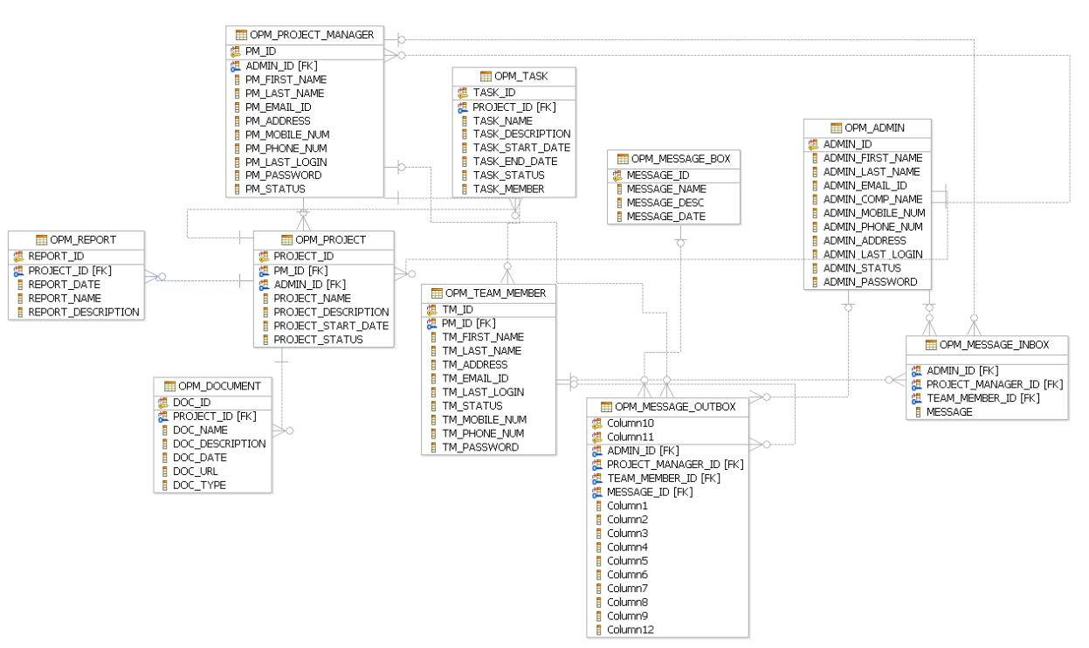

**2.3 Assumptions and Dependencies**

* The Project Manager from same company is not being assigned to two projects.
* Administrator can also be a project manager for a project.

**3. Specific Requirements**

**3.1 Functional Requirements**

**Users Module:**

* Administrator
* Project Manager
* Team Members

**General Functional Requirements:**

**R.1 Manage Authentication**

R.1.1 Login

Input: Username and Password

Output: Success or failure

Description: User can use this page to login to the system by entering personal credentials (username and password) and will be redirected to a home page to use the features of the website.

Constraints: Username must be text of at least 6 characters in length. Password must be at least 8 characters in length.

Process: Check the username and matching password in the database. If found in the database then redirect the user to his/her home page.

Exceptional Scenario: Show error message and ask the user for credentials again. If

the user attempts three consecutive failed logins, then deactivate the user account and show notification to user. User can contact admin for activating his/her account.

precondition: user must be registered on the website.

postcondition: user is logged in to the website and a new session is associated with the client connection.

R.1.2 Signup

Input: User details

Output: Success or failure

Description: User can use this page to sign up to the system by entering personal credentials (username, first name, last name, phone no., email and password) and will be redirected to a home page to use the features of the website.

Constraints: Username must be text of at least 6 characters in length. Password must be at least 8 characters in length.

Process: Check the username is not already used in the database. If found in the database then redirect the user to sign up page again with proper error message.

Exceptional Scenario: User is already registered to the system. In which case an appropriate message should be displayed and user should be redirected to the Login page.

precondition: user must not be registered on the website.

postcondition: user is logged in to the website and a new session is associated with the client connection.

R.1.3 Change the password

Input: User details [User email]

Output: Success or failure message

Description: User can use this page to change the password by entering personal credentials (email) and will be redirected to a home page to use the features of the website.

Constraints: email must be text of at least 6 characters in length. Password must be at least 8 characters in length.

Process: Check the email is already registered in the database. If found in the database then redirect the user to update password page again with proper success message.

Exceptional Scenario: User is not already registered to the system. In which case an appropriate message should be displayed and user should be redirected to the Register page.

precondition: user must be registered on the website.

**Functional Requirements of Administrator:**

**R.2 Manage Projects**

R.2.1 Create new project

Input: A form will open, necessary information will be entered like project name, key etc.

Output: Success or failure message

Description: when admin fills necessary details about the project, a new project will be created for the company.

Constraints: project with the same name should not be there in the company and length of the key should be min of 3 characters.

Process: A query will be fired to the database and an invitation email will be sent to the desired project manager.

Exceptional Scenario: User has entered the name of project which is already registered into the system. In which case appropriate error message should be displayed.

Precondition: admin must be logged in the system.

Postcondition: On success, new dashboard with the project name will be created and user will be redirected to the homepage of the website.

R.2.2 Invite new project manager

Input: email / username of the project manager

Output: Success message displaying “An email invitation has been sent to the PM”

Description: an invitation email will be sent to the project manager for confirmation.

Constraints: entered email should be valid and active

Process: An invitation email will be sent to the Project Manager. PM will confirm the request. Project information will be completed and status will be updated to ready.

Exceptional Scenario: email is invalid, in which case appropriate error message will be displayed to the user and user will be redirected to edit the page to enter an email again.

Precondition: admin must be logged in the system.

Postcondition: Success message will be displayed, and admin will be redirected to the team members’ page.

R.2.3 Manage Project manager

R.2.3.1 Remove project manager

Input: User selection

Output: Success message

Description: Project manager will be removed from the particular assigned project

.

Precondition: admin must be logged in the system.

Postcondition: Success message will be displayed, and admin will be redirected to the team members’ page.

R.2.3.2 update project manager details

Input: project manager details

Output: Success message

Description: Project manager details will be updated from the particular assigned project

.

Precondition: admin must be logged in the system.

Postcondition: Success message will be displayed, and admin will be redirected to the team members’ page.

**Functional Requirements of Project Manager:**

**R.3 Project Manager**

R.3.1 Manage team members

R.3.1.1 Invite new team member

Input: email / username of the team member

Output: Success message displaying “An email invitation has been sent”

Description: an invitation email will be sent to the team member for confirmation.

Constraints: entered email / username should be valid and active

Process: An invitation email will be sent to the team member. Member will confirm the request. Project information will be updated accordingly.

Exceptional Scenario: email is invalid, in which case appropriate error message will be displayed to the user and user will be redirected to edit the page to enter an email again.

Precondition: Project Manager must be logged in the system.

Postcondition: Success message will be displayed, and PM will be redirected to the team members’ page.

R.3.1.2 remove team member

Input: User selection

Output: Success message displaying “Team members has been removed”

Precondition: Project Manager must be logged in the system.

Postcondition: Success message will be displayed, and PM will be redirected to the team members’ page.

R.3.2 Manage tasks

R.3.2.1 Create new task

Input: task details

Output: Success message displaying “a new task has been added” and the task board will be updated

Description: PM starts a new task and assign team members to it.

Constraints: Team members should be registered to the system as well as well project

Process: A task will be added to the project and timelines will be displayed. Team members will update the task status and the project completion status will also be updated.

Exceptional Scenario: team member is not registered to the system, in which case appropriate error message will be displayed to the user.

Precondition: Project Manager must be logged in the system.

Postcondition: Success message will be displayed, and PM will be redirected to the team members’ page.

R.3.2.2 Delete task

Input: User selection

Output: Success message displaying “a task has been deleted” and the task board will be updated

Description: PM deletes an existing task from the task board.

Constraints: Task should be pre added to the task board to perform deletion.

Exceptional Scenario: team member is not registered to the system, in which case appropriate error message will be displayed to the user.

Precondition: Project Manager must be logged in the system.

Postcondition: Success deletion message will be displayed, and PM will be redirected to the team members’ page.

R.3.2.3 Update the task details

Input: updated task details

Output: Success message displaying “a task has been updated” and the task board will be updated

Description: PM updates any task by providing updated details of the task

Process: A query to the database will be made to fetch the current task details and the updated details will be saved to database.

Exceptional Scenario: fetching or updating of task details fails. In which case appropriate error message will be displayed and user will be redirected to the tasks page.

Precondition: Project Manager must be logged in the system.

Postcondition: Success message will be displayed, and PM will be redirected to the team members’ page.

R.3.3 Manage messages/comments

R.3.3.1 Add new messages/comments

Input: messages/comments

Output: A new message / comment will be added to the task/issue.

Description: PM add a new comment to the existing issue/task.

Precondition: Project Manager must be logged in the system.

Postcondition: Success message will be displayed, and PM will be redirected to the issue details page.

R.3.4 Provide documentation

R.3.4.1 Add new attachments

Input: attachment(s)

Output: A new attachment(s) will be added to the task/issue.

Description: PM add a new attachment to the existing issue/task.

Precondition: Project Manager must be logged in the system.

Postcondition: Success message will be displayed, and PM will be redirected to the issue details page.

R.3.4.2 Remove attachments

Input: User selection

Output: attachment(s) will be deleted from the task/issue.

Description: PM removes attachment from the existing issue/task.

Precondition: Project Manager must be logged in the system.

Postcondition: Success message will be displayed, and PM will be redirected to the issue details page.

R3.5 Generate Reports

Input: User selection

Output: Report will be generated and will be available to download in the downloadable format.

Process : Report will be generated and the database entry would be made for the same.

Description: PM can generate report for the existing project to see the various analytics.

Precondition: Project Manager must be logged in the system.

R3.6 Update project status/deadlines

Input: project details

Output: Success message

Description: PM can update the project status and its deadline .

Precondition: Project Manager must be logged in the system.

**Functional Requirements of Team member:**

**R.4 Team member**

R4.1 Update issue/task status

Input: User selection

Output: Success message

Description: Team member can update the issue/task status.

Precondition: team member must be logged in the system.

R4.2 Create new comment/message

Input: comment/message

Output: Success message and comment will be added to the issue details page

Description: Team member can comment or add a message to the particular task.

Precondition: team member must be logged in the system.

**3.2** **Non-Functional Requirements**

1. The system is resistant to faults within the system.
2. The system can be accessed from anywhere at all times.
3. The system is secure with attack protection, attack prevention by code side (Cross-

Site Scripting), encrypted communication channels (https)

1. The system can be accessed from mobile devices and desktop computers.
2. Supports the number of users at the same time more than 100 people.
3. The system can be used easily.
4. The system can support the growth of user base.

**3.3** **Supplementary Requirements**

Since this a tool which can be used from anywhere and anytime in the world, so the server should be well managed for such kind of requirement.

The users using this and importing the reports from this tool should have supporting software to run them.

To use the application in the best possible way please read the tips displayed while using the tool.